HORN & LAURETTI
225 FRIEND STREET, SUITE 204

BOSTON, MA 02114
(617) 589-3000

FAX (617) 523-3812
JOHN M. HORN DENISE M. LAURETTI*
MICHAEL S. KINSON* JEFFREY D. SWARTZ

*Admitted in MA and NH

Joseph F. Hennessey, Esquire
Defilippis, Kaldis & Hennessey, LLP
375 Broadway, Suite 2
Somerville, MA 02145

RE: SUBPOENA NOTICE
Savoy vs. Cushing
Middlesex County Superior Court Division Civil Action No.: 09-2581

Dear Attorney Hennessey:

The requisite ten-day period has passed and I have received no notification from you that any objection has been raised. I will assume there is no objection to this request for information and will so notify the Keeper of Records for the following locations:

James M. Peterson, M.D. (Medical Records)

Attached please find a copy of the letter issued to the above-mentioned facilities.

Thank you for your attention to this matter.

Very truly yours,
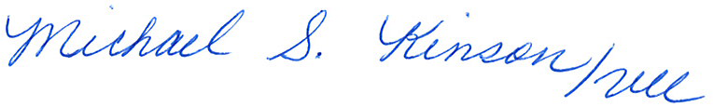

John M. Horn

MHM/vll
Enclosure
Cc: John P LeGrandJohn M. Horn

Order No. 01-18977-002

Staff Counsel: Hanover Insurance Company/Citizens Insurance Company
Not a Partnership

